**CAR GAME IN C++**

Project Submitted in Partial Fulfillment of the Requirements for the Degree of Bachelor of Technology in the field of Computer Science and Engineering

##### BY

Anik Sarkar (123210903207)

Manoj Sarkar (123210903226)

Arpan Ghosh (123210903212)

Sangramjit Das (123210903240)

Under the supervision

of

Jhilam Mukherjee

**

##### Department of Computer Science and Engineering

JIS College of Engineering

Block-A, Phase-III, Kalyani, Nadia, Pin-741235

West Bengal, India

May, 2020



**CERTIFICATE**

This is to certify that **Anik Sarkar (123210903207),** **Manoj Sarkar (123210903226), Arpan Ghosh (123210903212), Sangramjit Das (123210903240).** Has completed his project entitled **CAR GAME IN C++,** under the guidance of  **Jhilam Mukherjee** in partial fulfillment of the requirements for the award of the **Bachelor of Technology in Computer Science and Engineering** from JIS college of Engineering (An Autonomous Institute)is an authentic record of their own work carried out during the academic year 2021-22 and to the best of our knowledge, this work has not been submitted elsewhere as part of the process of obtaining a degree, diploma, fellowship or any other similar title.

**--------------------------------- ------------------------------- ------------------------------**

**Signature of the Supervisor Signature of the HOD Signature of the Principal**

**_________________________________**

**Signature of the External Expert**

**Place:**

**Date:**



ACKNOWLEDGEMENT

The analysis of the project work wishes to express our gratitude to Guide Name for allowing the degree attitude and providing effective guidance in development of this project work. His conscription of the topic and all the helpful hints, he provided, contributed greatly to successful development of this work, without being pedagogic and overbearing influence.

We also express our sincere gratitude to Dr. Dharmpal Singh, Head of the Department of Computer Science and Engineering of JIS College of Engineering and all the respected faculty members of Department of CSE for giving the scope of successfully carrying out the project work.

Finally, we take this opportunity to thank Prof. **(Dr.) Partha Sarkar**, Principal of JIS College of Engineering for giving us the scope of carrying out the project work.

Date:

**…………………………………….………………………………….**

Anik Sarkar

B.TECH in Computer Science and Engineering

2ND YEAR/ 3RD SEMESTER

University Roll-123210903207

**…………………………………….………………………………….**

Manoj Sarkar

B.TECH in Computer Science and Engineering

2ND YEAR/ 3RD SEMESTER

University Roll-123210903226

**…………………………………….………………………………….**

Arpan Ghosh

B.TECH in Computer Science and Engineering

2ND YEAR/ 3RD SEMESTER

University Roll-123210903212

**…………………………………….………………………………….**

Sangramjit Das

B.TECH in Computer Science and Engineering

2ND YEAR/ 3RD SEMESTER

University Roll-123210903240

**INTRODUCTION:**

Racing games are video games genre in which a player participates in a racing competition. We have created a racing game in c++ which can be enjoyable for kids, that the kids can enjoy passing time.

**CONCEPT:**

We have created a car game in c++, in which the car goes on a direct path. In that direct path there are many obstacles that coming in the car’s path. A player has to tackle the obstacles to defend the car to go in it’s way. By tackling the obstacles a player can also earn points. When the obstacle is crashed with the car, then the **GAME IS OVER.**

**INFORMATION:**

We use the A and D key to control the left and right movement of player’s car. We will keep track of the position of the car. When A or D key is pressed, we move the position of the car to the left or right lane and draw the car based on the position.

**HEADER FILES USED:**

**iostream:**

iostream **provides basic input and output services for C++ programs**. iostream uses the objects cin, cout, cerr, and clog for sending data to and from the standard streams input, output, error (unbuffered), and log (buffered) respectively.

**conio.h:**

conio.h stands for console input and output and .h represents it’s a header file.  
It’s not using for executing the code but for formatting the code and have various console input/output related functions to use within it like getchar, clrscr,getch etc.

**dos.h:**

dos.h header file of C language contains functions for handling interrupts, producing sound, date and time functions etc.

**time.h:**

This header file contains definitions of functions to get and manipulate date and time information.

**windows.h:**

**windows.h** is a Windows-specific header file for the C and C++ programming languages which contains declarations for all of the functions in the Windows API, all the common macros used by Windows programmers, and all the data types used by the various functions and subsystems.

**FUNCTIONS USED:**

**setcursor:** **Set the location at which subsequent text written to the LCD will be displayed**.

**gotoxy:** The gotoxy() function **places the cursor at the desired location on the screen**. This means it is possible to change the cursor location on the screen using the gotoxy() function. It is basically used to print text wherever the cursor is moved.

**COORD:** COORD is a structure to hold screen COORDinates X and Y.

**GetStdHandle:** GetStdHandle function returns a handle to standard device (input, output, or error).

**SetConsoleCursorPosition**: it sets the cursor position.

**Handle:** A **handle** is an index in system table which gives access to the Windows kernel object.

**STD_OUTPUT_HANDLE**: Std_Output_Handle() I suppose returns the STD_OUTPUT_HANDLE value to specify std output, active console buffer.

**OUTPUT:**

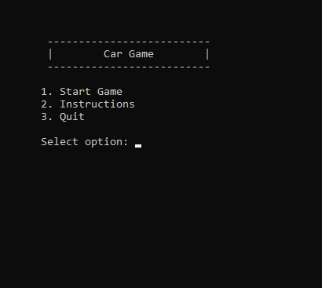

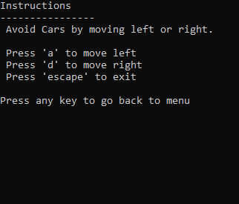

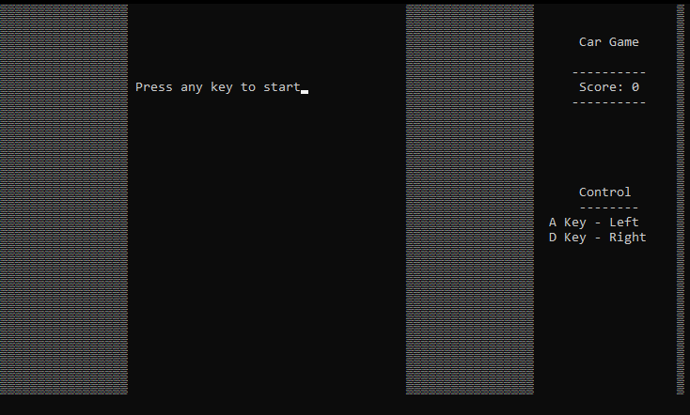

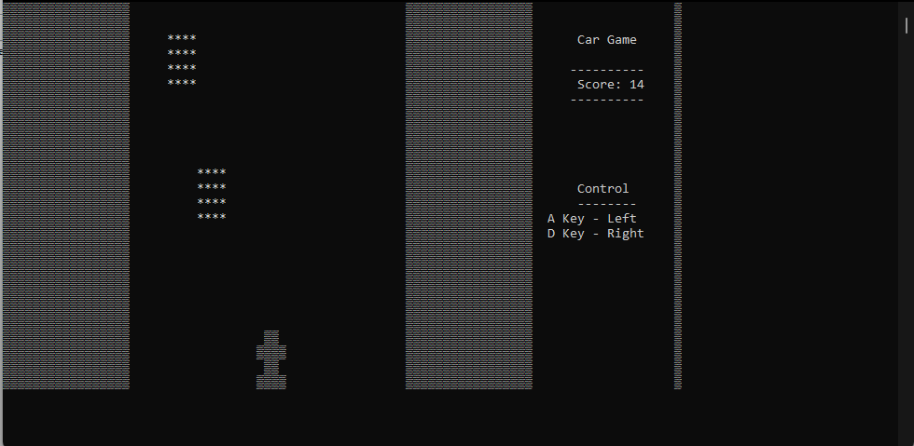

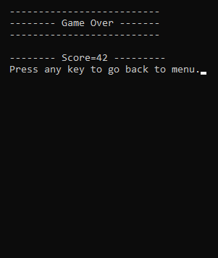

**CONCLUSION:**

In Dev C++, with the help of Function and header files we have created a car racing game that will be very enjoyable for the kids. So, we have very pleased that we have created this project.